Aapistie 5. Main building; repair of water damages
Repair of water damages that started from room 479B

Order of work and schedule
The work has already started. Demolition work will go on for about a week from now. Time period of drying of the structures is still a question. Repairing work will start as soon as possible.

Demolition work has started in the second floor. Next is third and then fourth floor. The working schedule and order of work can be changed during demolition work. The structures that need to be dried must be kept open for a time that is still unknown.

Measures and location
Aapistie 5. Working are marked with yellow paint.

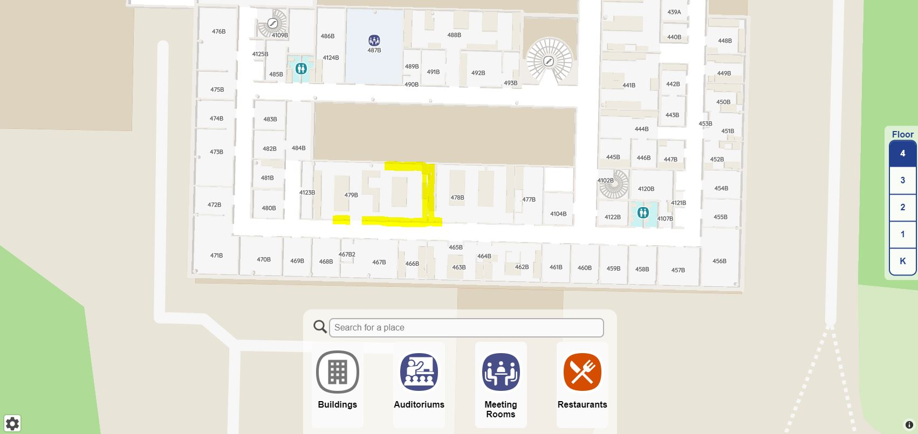

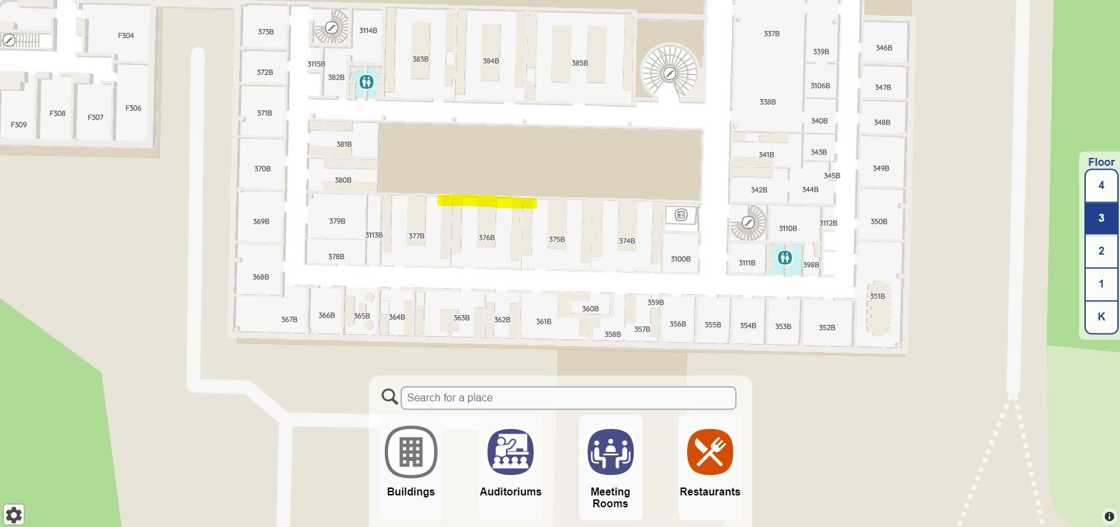

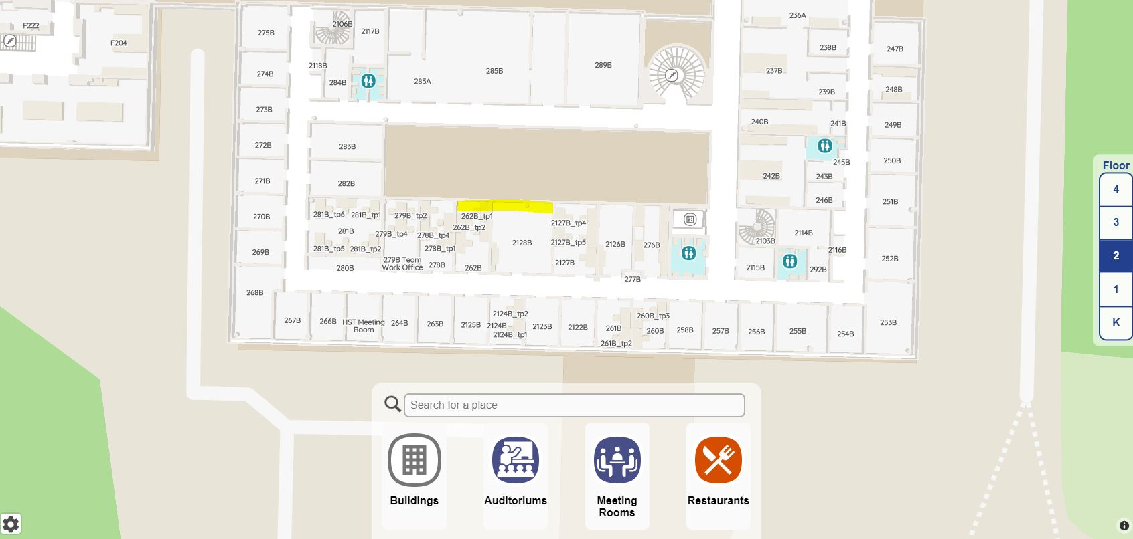

Performer of measures
ISS Palvelut Oy

Impact on property users
The measures have impact on the users of the property
Traffic restriction near working area may occur. The are also noise from time to time.

Additional information
Constraction site manager Antti Voutilainen 050 302 6810

We apologize for any inconvenience this may cause. We will be happy to help you with any questions you may have.

