TITLE

Author First¹, Author Second² & Author Third³
¹Address of the first author, e-mail address of the first author
²Address of the second author, e-mail address of the second author
³Address of the third author, e-mail address of the third author

INTRODUCTION

The Biocenter Oulu Day 2023 “Tools of life - Approaches for solving biochemical mysteries” will be organized on Wednesday 17th of May, 2023 in the main building of the Kontinkangas campus¹.
The tradition has been to publish a Biocenter Day bulletin, in which research groups have the opportunity to present their latest work as “mini-poster”. Your mini-poster topic is not expected to be related to the Day’s theme, because the idea is to present the current research of Biocenter Oulu.
This is a template you should use for your mini-poster; just replace the text with your own. You don’t need to include all the subtitles as such, but the page formatting (fonts, references, paragraphs, figures (no colour) etc.) should be kept as they appear in the template.

METHODS

The mini-posters will be printed in black-and-white, and the figures should be submitted in black-and-white or in grayscale. Please take this into consideration when presenting figures, as if you use images that are originally colored, you need to change them to grayscale (Fig. 1). Please also notice that the final size of the image will be reduced. Do not include illustrations that are not informative (Fig. 2).
Please leave one line blank before and after figures and tables. If it is necessary to include larger figures or tables that extend over two columns, insert them either at the beginning or the end of page. Make sure the figure resolution is high enough for printing.

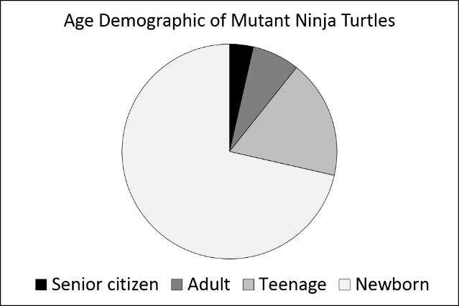
Figure 1. Figure text in Times New Roman 10, title in bold. Graph in grayscale with readable text.

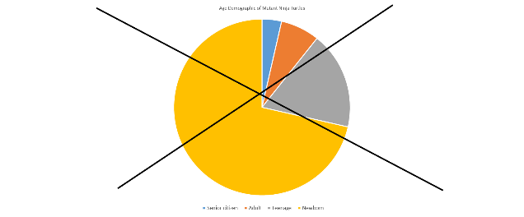
Figure 2. Example of a poor illustration: Colours will not be printed, too small text.

RESULTS

The total length of the mini-poster is one or two A4 pages. The final page size of the publication will be B5 (182 x 257 mm) when printed. Please keep this in mind when inserting images to the mini-poster.
(More results, data, tables etc. to fit the mini-poster to 1-2 pages.)

CONCLUSIONS

Following these instructions and using this template for your mini-poster, you will help us to make the Biocenter Oulu Day bulletin easy to read and browse through.
Deadline for the mini-posters is 21st of April 2023.
Please e-mail the mini-poster word document (saved in “docx”, or “rtf” format) to quoc.ngo@oulu.fi. Thank you!

REFERENCES

(1) Author A., Author B. & Author C. (Year). Title of the Research Poster. Publication. Vol: page no.-page no.

