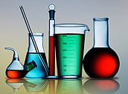
Washing and disinfection
in DWA Aapistie 7, F025

Dirty dishes and instruments are brought daily from all laboratories and cell cultures to room F025/DWA

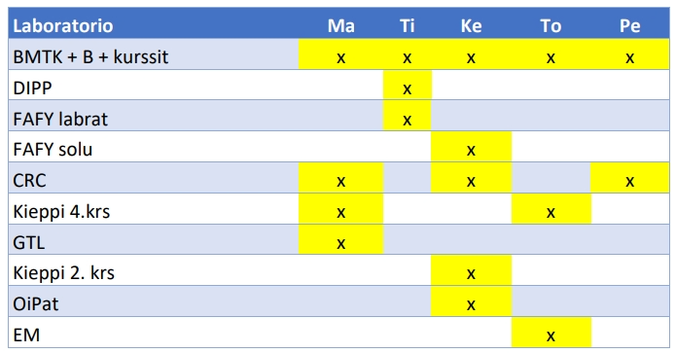
- Rinse all used laboratory glass and plastic ware before placing them in the dish bin.
- Remember to remove the markings, tapes and glue from dishes.
Do not leave dishes with dyes, chemicals or dishes with very stacked material for cleaning. Discard them by yourself in a proper way. You must know the risks of the chemicals not the DWA personnel. (Dyes harm other dishes and the machine).
Mark your dishes with your group´s logo!

- Remember to reserve washing time for cell culture incubator parts ( DWA-valinehuolto@oulu.fi ) Do not just bring them to the unit. Never bring them without reserving.

- The groups collect clean dishes daily from DWA

- Don`t hesitate to ask if some questions

