Autoclaving liquids in Kontinkangas campus

Liquids has to be brought in autoclaving room by 10:00 o’clock
- The liquid material has to be at room temperature (exceptions are always negotiable)

- maximum volume of liquids is 80 % of the nominal volume of the bottle.
  - e.g. 800 ml /1l bottle
larger volumes will boil out from the bottles
= loss in volume = changes in concentration
= mess in the autoclave (hours of cleaning)

!! Overfilled Bottles will not be autoclaved in future!!

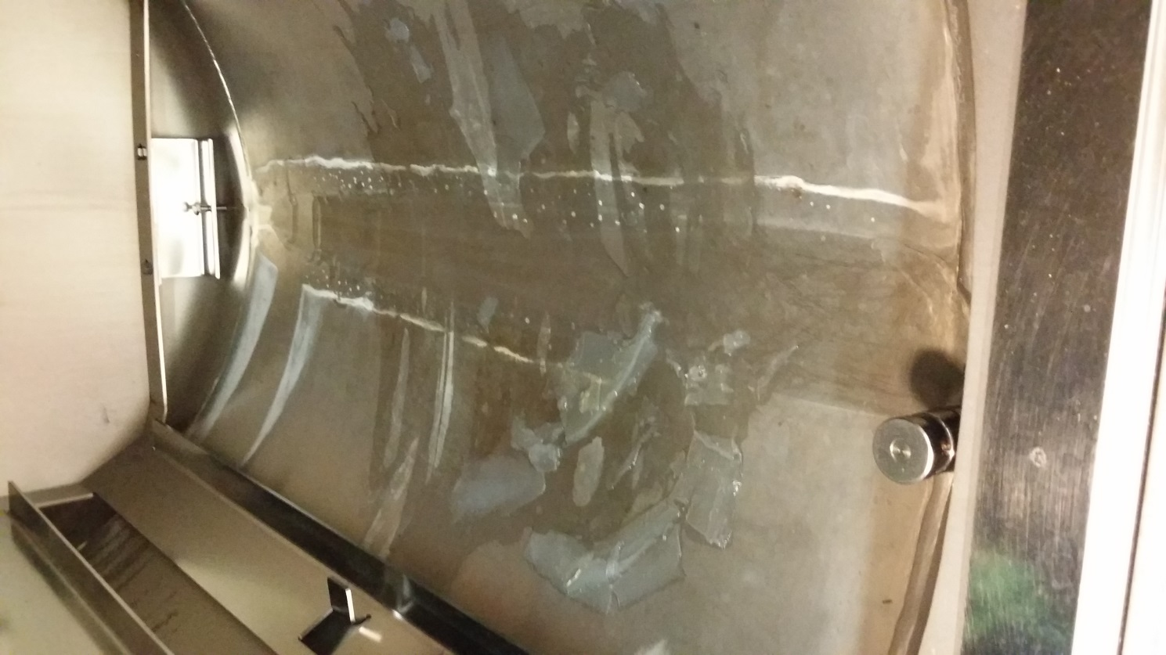
Very bad example from today !!

