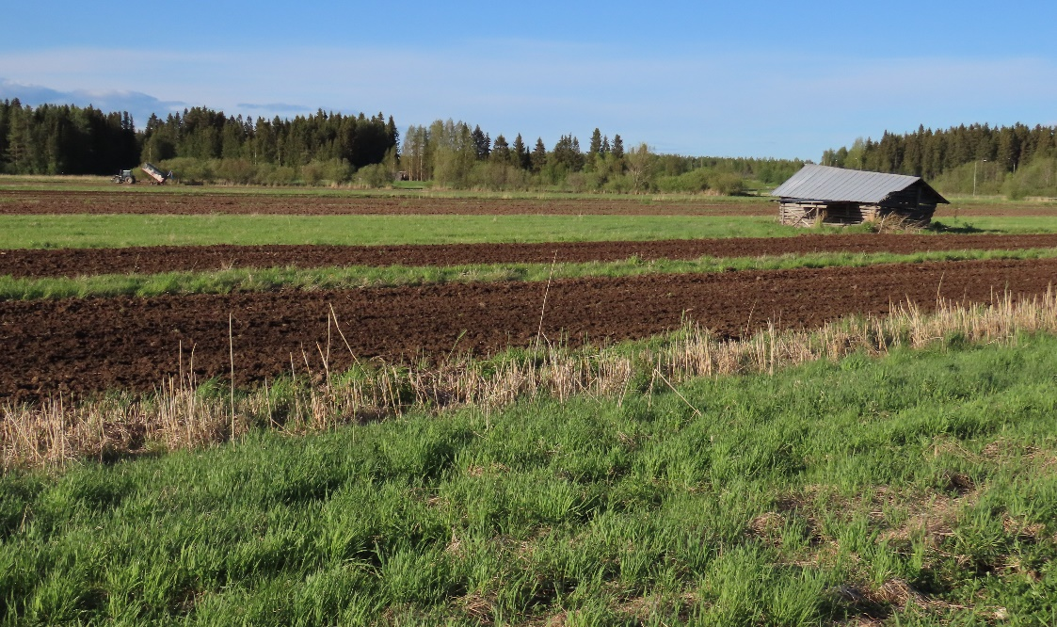
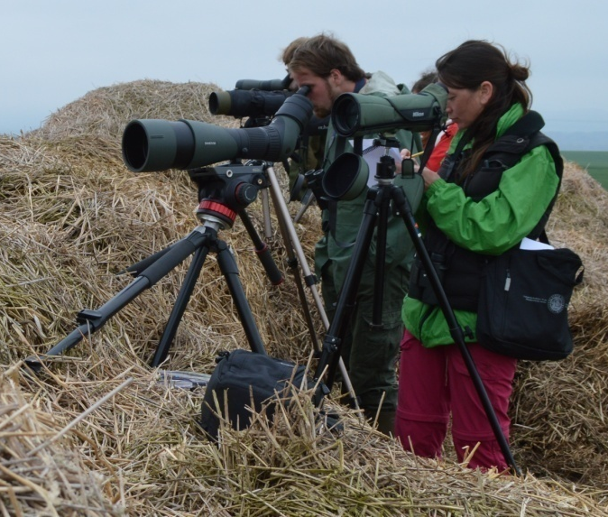

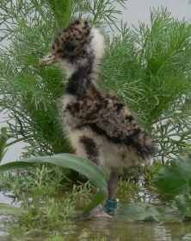

Shorebird fieldwork opportunity in Oulu region, Finland, spring 2025
Description:
Within the international ERC CZ project: Animal migrations in a changing world: still advantageous strategy or maladaptive behaviour? and our Global Life-history, Ornithology & Behavioural Ecology (GLOBE) research group (Principal Investigator and Group Leader: Dr. Vojtěch Kubelka https://zoo.prf.jcu.cz/index.php/staff-item/kubelka-vojtech/?lang=en) and with cooperation with Oulu University, we are investigating in detail breeding performance and benefits for migratory behaviour in shorebirds at various locations. Here, we are searching for a motivated researcher/student to work as a field assistant or becoming student in our international team in Oulu region working with Northern Lapwings and other shorebirds. Fieldwork consists mostly of nest search, observations and experimental work with artificial nests and traps for monitoring arthropod abundance through the breeding season. For details get in touch or check our previous project: https://elvonalshorebirds.com/documents/.
Skills requested:
The ideal candidate will have fieldwork experience with breeding shorebirds or at least birds, a good health condition and is willing to work in agricultural landscape within international team. Experience with bird ringing and driving licence is beneficial but not essential.
Training offered and benefits:
Resighting of colour-ringed/banded birds with binoculars and scope, detailed standardized behavioural observations, nest searching, floating eggs, conducting experiments with artificial nests and pitfall traps. In case of interest also trapping and handling shorebirds, taking blood and faecal samples. On top of the salary, the research costs during the fieldwork for the chosen candidate will be covered. In case of establishing a shared international studentship (MSc, Ph.D.), more support is possible.
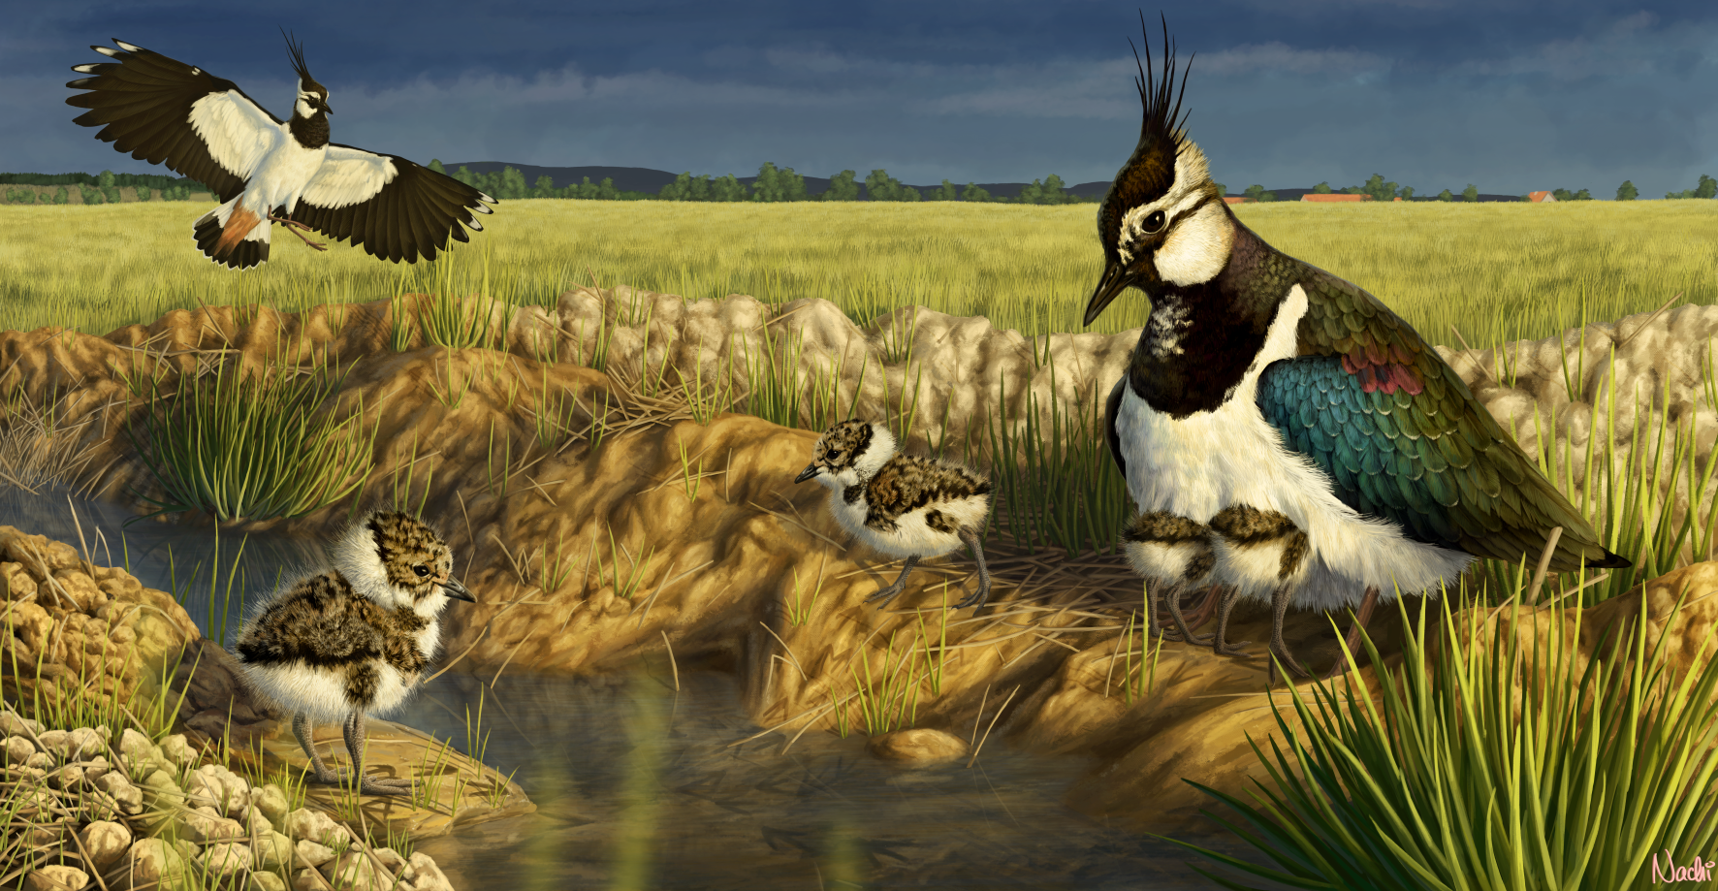
Interested candidates should contact Andreas Rimoldi (rimoldi.andreas@yahoo.com) with applications that include max one page motivation letter and max three pages CV highlighting relevant experience and referees. Documents in English should be sent to Andreas Rimoldi via aforementioned e-mail. Deadline: 31 March 2025.

