Finnish Carrot Casserole
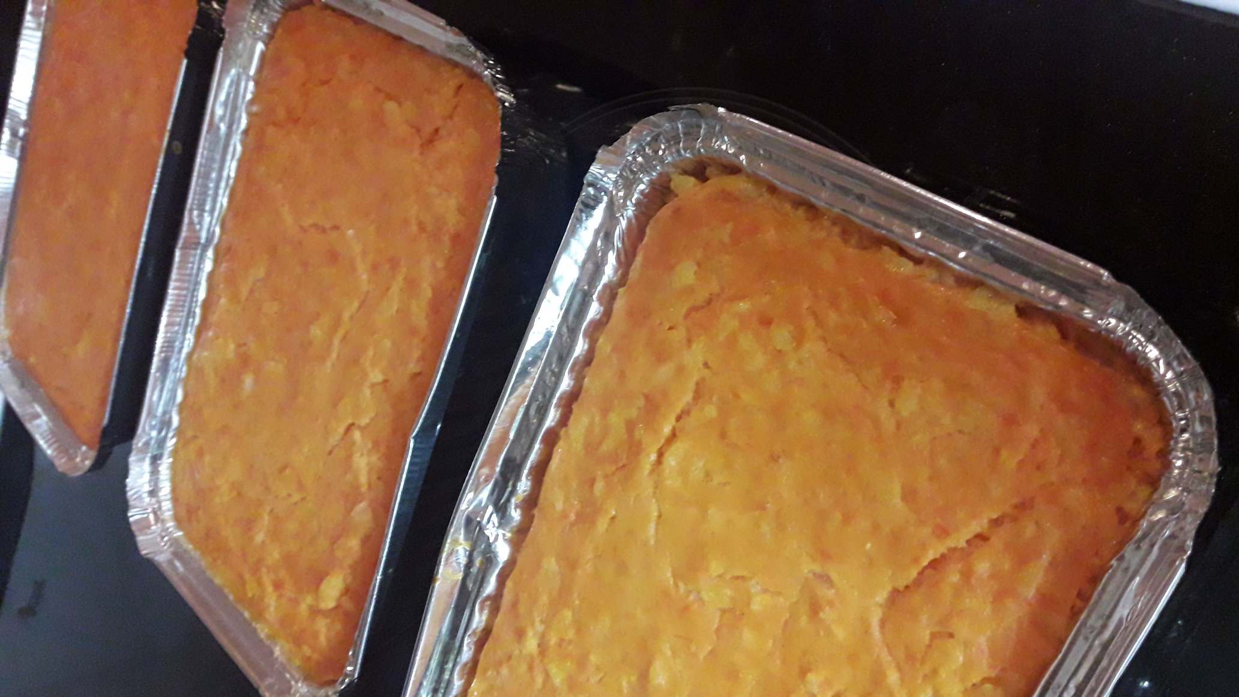
Ingredients
500 g carrots
2.5–3 dl water
¾ dl rice
2.5 dl whole milk (lactose free)
1 teaspoon salt
1 egg

Directions
- Peel and cut up carrots, place them in a saucepan and cover with water; bring to a boil. Cook until crisp-tender.
- Remove carrots from the cooking water and add rice in the water to cook. Add milk and cook over a low heat for about 40 minutes – remember to stir. Now you have rice porridge. Let it get cool.
- Mush carrots and mix with rice porridge. Add egg and salt and mix well.
- Grease a baking dish and fill it with carrot-porridge-mixture. Bake at 200 °C for 60 minutes.

