TITLE

Author First¹, Author Second² & Author Third³
¹Address of the first author, e-mail address of the first author
²Address of the second author, e-mail address of the second author
³Address of the third author, e-mail address of the third author

INTRODUCTION

The Centre For Life-course Epidemiology, University of Oulu organizes a Conference on Epidemiological Birth Cohort Studies on the 12th and 13th of June 2014 in the main building of the medical campus, in Leena Palotie Auditorium, Aapistie 5, Oulu¹.
We will publish an abstract book, in which researchers involved in the Northern Finland Birth Cohort Studies can present their currently ongoing research. This is a template you can use for your abstract; just replace the text with your own. You don’t need to include all the subtitles as such, but the page formatting (fonts, references, paragraphs, figures, etc.) should be kept as they appear in the template.

METHODS

The abstracts will be printed in black-and-white. Please take this into consideration when presenting pictures. If you wish to present pictures, figures or tables here is an example (Fig. 1).

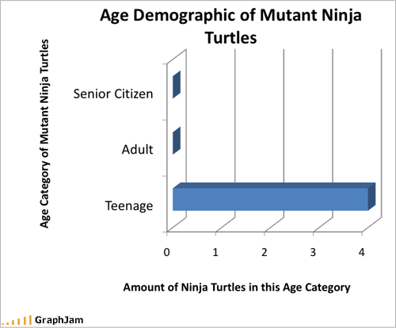

Figure 1. Figure text in Times New Roman 10, title in bold.

Please leave one line blank before and after pictures, figures and tables. If it is necessary to include larger figures or tables that extend over two columns, insert them either at the beginning or the end of page. Make sure the figure resolution is high enough for printing.

RESULTS

The total length of the abstract is two pages B5 (182 x 257 mm). This is the final size of the publication.

CONCLUSIONS

Please use the template provided for your abstract. This will make the abstract book easier to read and browse through.
Deadline for the abstract is Thursday 8th of May 2014. Please e-mail the abstract word document (saved in “doc”format) to saranya.palaniswamy@oulu.fi

REFERENCES

(1) Author A., Author B. & Author C. (Year). Title of the Research Article. Publication. Vol: page no.-page no.

