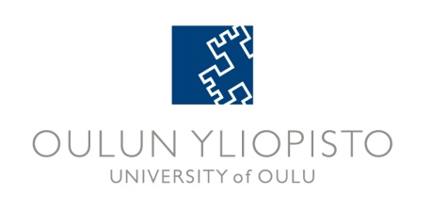
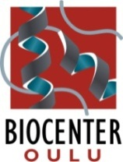
BIOCENTER O ULU SEMINAR SERIES
Autumn 2013 PROGRAM

Time: 15.15-16.00 unless otherwise indicated in the program
Coffee is served during the networking session before the seminars
Place: Linnanmaa Campus: PR101
Medical Campus Aapistie: Lecture hall A101 (Anatomy), F101 (Physiology), or Auditorium 101A (Leena Palotie Hall)
Registration: No registration required
Transportation: Bus transportation is arranged between Medical and Linnanmaa Campuses
Information: Pirkko Huhtala, tel. 486101, Ext. 0294 486101, e-mail pirkko.huhtala(at)oulu.fi

Place | Speaker | Title
October 10  Medical Campus  Auditorium 101A (Leena Palotie Hall)  Host:  Taina Pihlajaniemi | Christer Betsholtz  Uppsala University  Dept. Immunology, Genetics and Pathology,  and Karolinska Institutet  Dept. Medical Biochem. and Biophysics, Div. Vascular Biology, Stockholm, Sweden | Pericyte-endothelial cell interactions in blood vessel development and disease
October 17  Medical Campus  F101 (Physiology)  Host:  Gonghong Wei | CANCELLED, new date May 15  Jianfeng Xu  Center for Human Genomics and Personalized Medicine and Center for Cancer Genomics,  Wake Forest School of Medicine, Winston-Salem, USA | Genetics of prostate cancer: discovery and clinical utility
October 31  Medical Campus  A101 (Anatomy) | BCO Pihlajaniemi Group  Vanessa López, Mari Aikio and Valerio Izzi  Dept. of Med. Biochem. and Mol. Biol.,  Institute of Biomedicine, Univ. of Oulu | Multiplexin collagens as microenvironmental regulators
November 7-9  Kuopio | BCO-BCK Minisymposium in Kuopio | Separate program
November 21  Linnanmaa PR101  Host:  Lloyd Ruddock | Alexander Frey  Molecular Biotechnology at Aalto University,  School of Chemical Technology, Helsinki | Building antibody factories – towards the humanization of expression hosts
November 28  Linnanmaa PR101  Host:  Kalervo Hiltunen | Marja Mikkola  Institute of Biotechnology,  University of Helsinki | Development of the mammary gland
December 3  NOTE Tuesday!  Medical Campus  F101 (Physiology)  Host:  Johanna Myllyharju | CANCELLED, new date April 10  Liliana Schaefer  Pharmazentrum Frankfurt  Dept. of Nephropharmacology, Institute of Pharmacology and Toxicology,  University of Frankfurt/Main, Germany | Decoding SLRP signaling in inflammation
December 12  13.00-16  Linnanmaa L10 | Discovery of the Year | Separate Program

Bus transportation: Medical Campus-Linnanmaa-Medical Campus: The bus leaves from Kieppi Building Aapistie 5A, 30 min before the scheduled beginning of the lecture, and returns after the lecture from Linnanmaa Door J (Biochemistry) to Aapistie 5A.
Linnanmaa-Medical Campus-Linnanmaa: The bus leaves from door J (Biochemistry) 30 min before the scheduled beginning of the lecture. Return from Kieppi building Aapistie 5A back to Linnanmaa door J.
Study credits: Contact ritva.saastamoinen(at)oulu.fi. Validation for 1 ECTS study credit requires attending 27 seminars.

The seminars are open for everybody. Welcome!

