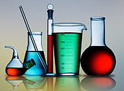
Biological waste
Autoclaving
in Aapistie 7, F037

Bring the biowaste bins in the room F037
Waste is autoclaved at room temperature. When you bring frozen waste, write a note: Date and frozen
The common maximum amount of liquid waste is 1 liter/waste bins/canister.
Blood tubes must be delivered in canisters marked: blood tubes.

- Mark the waste bin with label : WET or DRY
- If the main waste is dry, but if there is recognizable amount of liquid in the bag => WET
- liquefying material eg. agar => WET

- Close the bags with a stapler (be found nearby)
- Waste bags must be brought in a waste bin

  - Clean bins and wastebag can be found in room F037

- Please do not store full bins in your lab, let them cycle.

