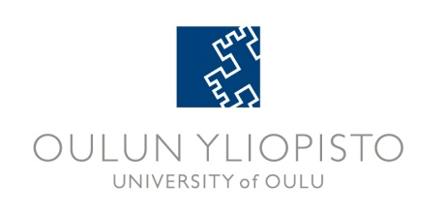
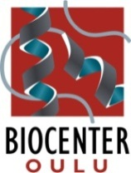
BIOCENTER O ULU SEMINAR SERIES
SPRING 2014 PROGRAM_DRAFt1

Time: 15.15-16.00 unless otherwise indicated in the program
Coffee is served during the networking session before the seminars
Place: Medical Campus: Aapistie 7A, A101 Anatomy or F101 Physiology
Linnanmaa Campus: PR102
Registration: No registration required
Information: Pirkko Huhtala, tel. 0294 486101, e-mail pirkko.huhtala(at)oulu.fi

Date and Place | Speaker | Title
January 8 Wednesday 13.15-14  Medical Campus  A101, Anatomy  Host:  Robert Winqvist | Liisa Kauppi  Research Program in Genome-Scale Biology  and Institute of Biotechnology,  University of Helsinki | Dissecting mechanisms of mammalian genome stability
February 13  Medical Campus  A101, Anatomy  Host:  Aki Manninen | Ünal Coskun  Membrane Biochemistry  Paul Langerhans Institute Dresden, Dresden, Germany | Regulation of growth factor receptor by lipid allostery
February 20  Medical Campus  A101, Anatomy  Host:  Gonghong Wei | Jussi Taipale  Department of Biosciences and Nutrition,  Karolinska Institutet,  Stockholm, Sweden | Systems Biology of Cancer
February 27  Linnanmaa, PR102  Host:  Thomas Kietzmann | Urs Albrecht  Departments of Biology and Biochemistry, University of Fribourg,  Fribourg , Switzerland | The circadian clock and its impact on physiology and behavior
March 20  Linnanmaa, PR102  Host:  Petri Kursula | Janos Hajdú  Laboratory of Molecular Biophysics, Department of Cell and Molecular Biology, Uppsala University, Sweden | TBA
March 26 | Biocenter Day | Blood, Juice of Life (Separate program)
April 3  Medical Campus  A101, Anatomy  Host:  Karl-Heinz Herzig | Johannes le Coutre  Perception Physiology,  Nestlé Research Center,  Lausanne, Switzerland | Taste, the metabolic sense
April 10  Medical Campus  A101, Anatomy  Host:  Johanna Myllyharju | Liliana Schaefer  Pharmazentrum Frankfurt  Dept. of Nephropharmacology, Institute of Pharmacology and Toxicology,  University of Frankfurt/Main,  Germany | Decoding SLRP signaling in inflammation
April 24  Medical Campus  A101, Anatomy  Host:  Sylvain Sebert | Vincent Prevot  Jean-Pierre Aubert Research Center,  Development and Plasticity of the Postnatal Brain  Inserm U837/University of Lille,  Lille, France | Semaphorin 3A/Neuropilin-1 Signaling in GnRH System Development and Adult Plasticity
May 6 (Tuesday!)  Linnanmaa, PR102  Host:  Outi Savolainen | Miltos Tsiantis  Department of Comparative Development and Genetics  The Max Planck Institute for Plant Breeding Research, Cologne, Germany | Towards understanding development and diversity of leaf shape
May 15  Medical Campus  A101, Anatomy  Host:  Gonghong Wei | Jianfeng Xu  Center for Human Genomics and Personalized Medicine and Center for Cancer Genomics,  Wake Forest School of Medicine,  Winston-Salem, USA | Genetics of prostate cancer: discovery and clinical utility
May 22  Medical Campus  A101, Anatomy  Host:  Taina Pihlajaniemi | Gerard Karsenty  Columbia University Medical Center  Department of Genetics & Development, New York, USA | Contributions of Bone to Whole-Organism Physiology
May 27 (Tuesday!)  Medical Campus  F101, Physiology  Host:  Johanna Myllyharju | Massimiliano Mazzone  VIB Vesalius Research Center  University of Leuven,  Leuven, Belgium | Modulating the hypoxic response of cancer cells and tumor stroma: implication for therapy

Study credits: Contact ritva.saastamoinen(at)oulu.fi. Validation for 1 ECTS study credit requires attending 27 seminars.

The seminars are open for everybody. Welcome!

