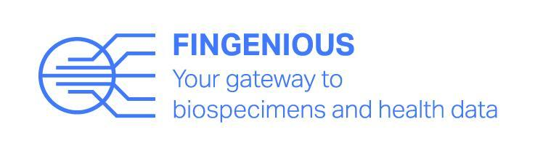
FINGENIOUSTM – your gateway to biospecimens and health data
Undertaking biobank research is getting easier and faster. Through FINGENIOUSTM you can now reach all six Finnish hospital biobanks by completing just one feasibility and access request. FINGENIOUSTM helps both academics and businesses to investigate the availability of biobank samples and related data.
FINGENIOUSTM is a Finnish Biobank Cooperative (FINBB) service that allows researchers to approach all hospital biobanks using one access request. Participating are: Auria Biobank, Helsinki Biobank, Biobank of Eastern Finland, Biobank of Central Finland, Biobank Borealis and Finnish Clinical Biobank Tampere.
The goal of FINGENIOUSTM is to make it simpler for the researcher to work, improve research and product development and enhance Finland’s competitiveness as a research environment. The standard of biobank research in Finland is exceptionally high, with a vast collection of samples and data.
Previously the researcher had to approach each biobank using separate access requests and with different processes. FINGENIOUSTM has united the processes where the researcher is able to request feasibility details from or access to different biobanks with just one form. This is a faster and easier way to start the research process.
With FINGENIOUSTM it is easy to keep track of how the research process is going and it is transparent. Researchers are able to follow how their project is proceeding in the biobanks in real-time.
Feasibility enquiries and access requests through the service are free of charge for the researcher. In feasibility requests which are exceptionally large, the costs will be estimated separately. Researchers will be able to get the estimation of total project costs during the FINGENIOUSTM feasibility report and access request process.
You can find the FINGENIOUSTM service from the FINBB website as well as from all of the participating biobanks’ websites. The service website is www.fingenious.fi
- You can reach all Finnish hospital biobanks and their data simultaneously
- One access request is enough
- Researchers will find the process faster and easier
- Feasibility results covering all of Finland’s hospital biobanks within 2-3 weeks

You can get more information from Eeva Kronqvist, Director, Services, FINBB (eeva.kronqvist@finbb.fi, +358 40 566 1586) and from Anne-Mari Moilanen, Project Manager, Northern Finland Biobank Borealis (anne-mari.moilanen@ppshp.fi, +358 50 560 8137.
