PostDoc position available
At the Mitovasc Institute, UMR 6015 CNRS / 1083 INSERM, Angers, France, we are seeking a highly motivated PostDoc candidate
Funded by the the French Agence Nationale de la Recherche (ANR) and Deutsche Forschungsgemeinschaft (DFG), we will study in a common project with the University of Köln, Germany (AG Wiesner), the effect of accumulating mitochondrial DNA mutations on heart function during aging. Using a newly developed mouse model, we have shown that the stochastic accumulation of such mutations in single cardiomyocytes, giving rise to a tissue mosaic with only one out of two hundred cells severely affected, leads to severe cardiac arrhythmia in mice (Baris et al., Cell Metab 2015). In order to understand the pathomechanisms leading to this important ageing associated cardiac disease, we will now study
- the interaction of defective cells with the surrounding tissue and
- if acceleration or slowing down the rate of mutation accumulation accelerates or slows down the progression of the disease.
Methods: Breeding and handling of genetically modified mice, immunohistochemistry, Multi-OMICs approaches (NGS, metabolomics), and cardiac function exploration (telemetry, echocardiography).
Background on mitochondrial biology and/or cardiac physiology would be helpful.
For more information see:
http://mitovasc.univ-angers.fr/en/research/research-themes/physiopathological-influence-of-mitochondrial-genome-instability-during-aging.html
The position is available any time starting from April 2021 for 24 months.
Send applications to Dr. Olivier R. Baris, Olivier.baris@univ-angers.fr
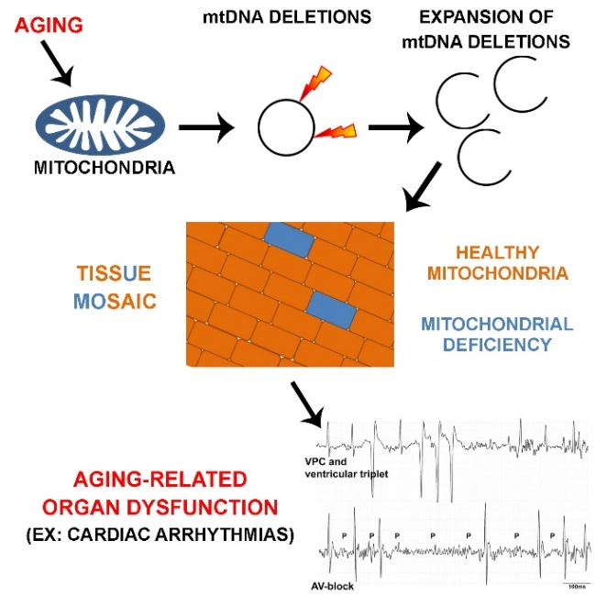

Baris OR, Ederer S, Neuhaus JF, von Kleist-Retzow JC, Wunderlich CM, Pal M, Wunderlich FT, Peeva V, Zsurka G, Kunz WS, Hickethier T, Bunck AC, Stöckigt F, Schrickel JW, Wiesner RJ. (2015) Mosaic Deficiency in Mitochondrial Oxidative Metabolism Promotes Cardiac Arrhythmia during Aging. Cell Metab. 21(5):667-77.

