DWA service in Kieppi during summer 2023

please notice the important dates:

No washing nor autoclaving of cell incubator parts 16.6.- 6.8.2023

There is reduced DWA service in Kieppi,
week 26 service only Thu 29.6 – Fri 30.6.
week 27 service only Tue 4.7 – Wed 5.7.
weeks 28 – 31 NO DWA SERVICE 10.7- 6.8.

For the users of the Kieppi DWA unit, please bring the dishes to the FBMM unit, room F025, by yourself.
The autoclave is in the room F043A, please bring the items to be autoclaved in this room.
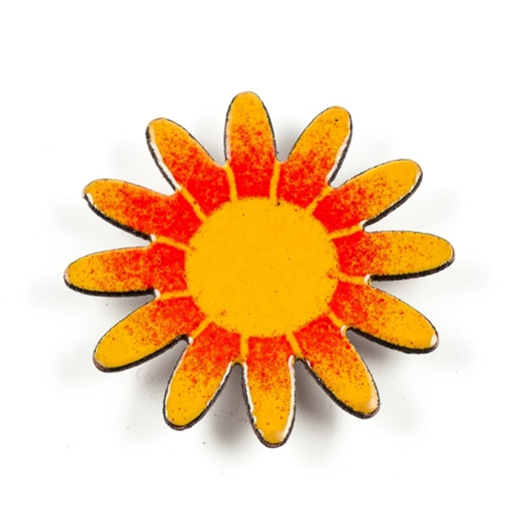
The waste to be autoclaved must be brought to room F037B.
Back in normal service on Mon 7.8.

Thank you for your cooperation
BR Virpi

