DWA service in FBMM during summer 2023

please notice the important dates:
No washing nor autoclaving of cell incubator parts 16.6.- 6.8.2023

There is daily DWA service in FBMM, except
week 28 service only Tue 11.7 – Thu 13.7.

BSL2 waste handling must be notified and agreed in advance between June 26 and August 4, 2023. Please send e-mail to DWA-valinehuolto@oulu.fi latest by noon in previous day.
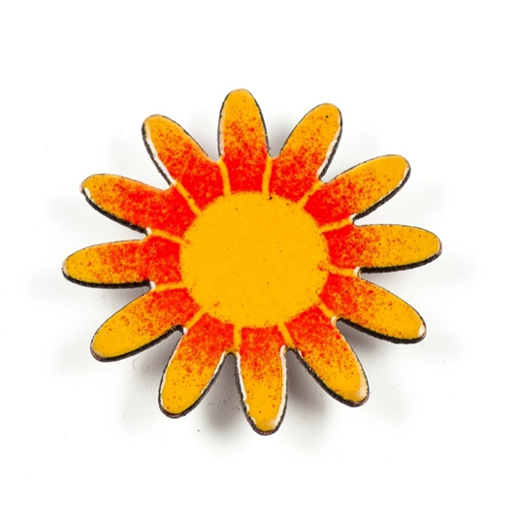
Back in normal service on Mon 7.8.

Thank you for your cooperation
BR Virpi

