BIOCENTER OULU DAY 2025
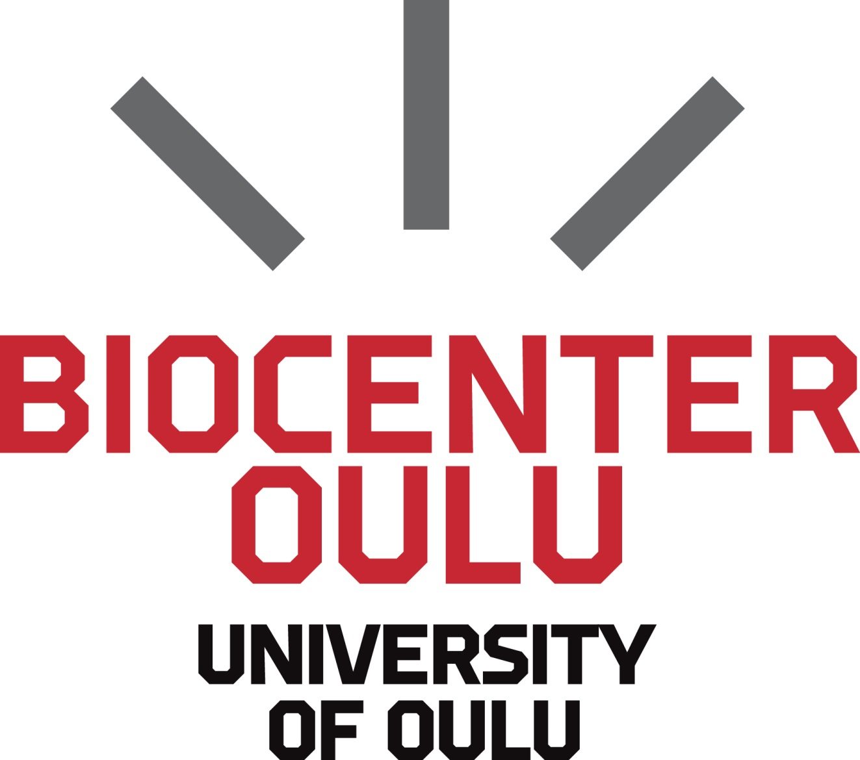
Mode the code – innovations in gene therapy
Time Thursday April 10, 2025, at 8.30-16.00
Place Leena Palotie Auditorium 101A in the Main Building of Kontinkangas Campus,
University of Oulu, Oulu, Finland
Chairpersons Ruwandi Abeysekara, Saurabh Singh Dhakar, Johanna Helenius
PROGRAMME
 | 8.30-8.40 | Opening remarks  Chairperson of the Organizing Committee, Biocenter Oulu
 | 8.40-8.50 | Welcome  Prof. Johannes Kettunen, Director of Biocenter Oulu
 | 8.50-9.30 | KEYNOTE  Seppo Ylä-Herttuala, UEF, Finland
 | 9.30-10.15 | Coffee at the exhibition area
Session 1: Gene editing
 | 10.15-10.20 | Sponsor spot
 | 10.20-10.50 | "Cancer-safe cell and gene therapy platform". Kirmo Wartiovaara, University of Helsinki, Finland
 | 10.50-11.20 | “Balancing efficacy and safety in lentiviral vector-mediated hematopoietic stem cell gene therapy”. Eugenio Montini, SR-Tiget, Italy
 | 11.20-11.25 | Sponsor spot
 | 11.25-12.55 | Lunch break and exhibition
Session 2: Delivery
 | 12.55-13.00 | Sponsor spot
 | 13.00-13.30 | “Blood derived applications of Nanofibrillated cellulose for future chronic wound treatment”. Marjo Yliperttula, University of Helsinki, Finland
 | 13.30-14.00 | “Folding of DNA and mRNA Origami for Controlled Translation and Viral Vector Packaging”. Mauri Kostiainen, Aalto University, Finland
 | 14.00-14.40 | Coffee at the exhibition area
Session 3: From bench to bedside
 | 14.40-14.45 | Sponsor spot
 | 14.45-15.15 | “Cancer gene therapy with oncolytic viruses: a learning cycle between the laboratory and patients”. Akseli Hemminki, University of Helsinki, Finland
 | 15.15-15.45 | “Matritools: a collection of open access methods to study the matrisome in the omics era”. Valerio Izzi, University of Oulu, Finland
 | 15.45-16.00 | General discussion and concluding remarks

