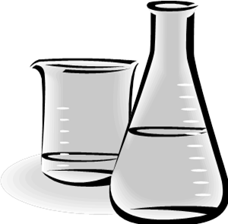
About Autoclaving
Biological waste
in Kieppi 2nd floor
Bring the waste bins in the Room 237B
- Mark the waste bin with label : LIQUID or SOLID
- If the main waste is dry, but if there is recognizable amount of liquid in the bag => LIQUID
- liquefying material eg. agar => LIQUID

- Close the bags with the stapler (can be found nearby)
- Never bring plain bags. The bags have to be in bins!

- Do not bring more than 2 waste bins per day (there is lot of waste to be autoclaved and we can handle max. 8 bins w/ liquid per day).

  - Clean bins can be found in room 239B (max 2 per day!)

- Please do not store full bins in your lab, let them cycle.

