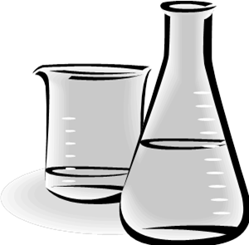
About Autoclaving
in Kieppi
Liquids has to be brought in the Room 236B by 10:00 o’clock
- The liquid material has to be at room temperature (exceptions are always negotiable)
- Maximum volume of liquids is 80% of the nominal volume of the bottle.
  - e.g. 800 ml /1l bottle
  - Pure water is the only exception, there you can use 100% fill-up.

- Maximum size of a bottle is 1000 ml (bigger bottles extend the autoclaving cycle remarkably, even by 1 hour!!)
  - one autoclaving cycle lasts about 2 – 2.5 h with 1 l bottles
  - Use only hot air tapes to mark bottles!

Labware (plastics, glass etc.) should be brought for autoclaving by 13:00 o’clock
If you want to have it in use in the following morning

- labware is autoclaved throughout the day
  - one autoclaving cycle takes about 50 min
  - if you are in a hurry with autoclaving, please ask help from the DWA personnel

