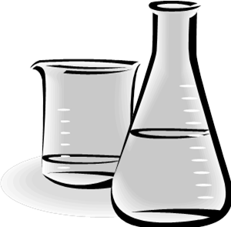
Washing and disinfection
in DWA facilities in Kieppi 2nd floor
Bring dirty dishes every day to DWA room 237B
- Rinse all used laboratory glass and plastic ware before placing them in the dish bin.
- Remember to remove the markings, tapes and glue from dishes.
Do not leave dishes with dyes, chemicals or dishes with very stacked material for cleaning. Discard them by yourself in a proper way. You know the risks of the chemicals not the DWA personnel. (Dyes harm other dishes and the machine).

- Remember to reserve washing time for the parts of cell culture incubators. Do not just bring them to the unit. Either reserve a suitable time contacting the DWA personnel or write the reservation time in the calendar (in room 236B). Only one incubator per day.

- The groups collect clean dishes daily from the room 236B

- You can ask help from the DWA personnel

