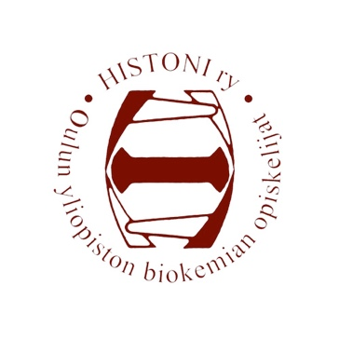
Histoni ry, Biochemistry students of University of Oulu
Meeting invitation
Meeting of the board 1/2020
The guild room of Histoni ry, Kontinkangas
14.1.2020, at 17:00

Agenda 1/2020

- Opening of the meeting
- Legality and quorum
- Election of the examiners of the minutes
- Approval of the agenda
- Change of allowance for bank account and internet bank usage
- Change of signature rights
- Appointment of the Anniversary representative
- Notifications
- Purchases
- Greetings from OLuT ry
- Acception of the bills and other finances
- Tutors 2020
- Honorary academic decorations of OYY
- Feedback survey 2019
- Events
9.1 The Annual Spring meeting
9.2 Kemiat Kohtaa 30.1.-1.2.
9.3 Kulti ry’s excursion
9.4 Shrove Tuesday sauna with OLTO ry
9.5 Histombly
9.6 World Cup of Kyykkä 22.2.2020
9.7 Other events
- Other bussiness
- Closing of the meeting

In Oulu 10.1.2020

_______________________________
Susanna Kirsilä, head of the board

