BIOKEMIAN JA MOLEKYYLILÄÄKETIETEEN TIEDEKUNTA
FACULTY OF BIOCHEMISTRY AND MOLECULAR MEDICINE

Opetuksen palautepäivä
Teaching feedback day

Wednesday 7.5.2014 at 09:00 - 12:00 in L7

09:00 Coffee and pulla

09:10 Feedback summaries by students (10 minutes max. each)
09:10 First year
09:20 Second year
09:30 Third year
09:40 Fourth to Fifth year / Master Degree
09:50 Word by the Faculty

10:10 take more coffee and pulla if there is any left

10:15 General discussion
(the lecture hall has been booked for us until 12:00)

After the completion of the discussion:
- Teacher of the Year award
- Bachelor Thesis award
- Histoni´s awards

Afternoon program: Traditional football match Students vs. Teachers
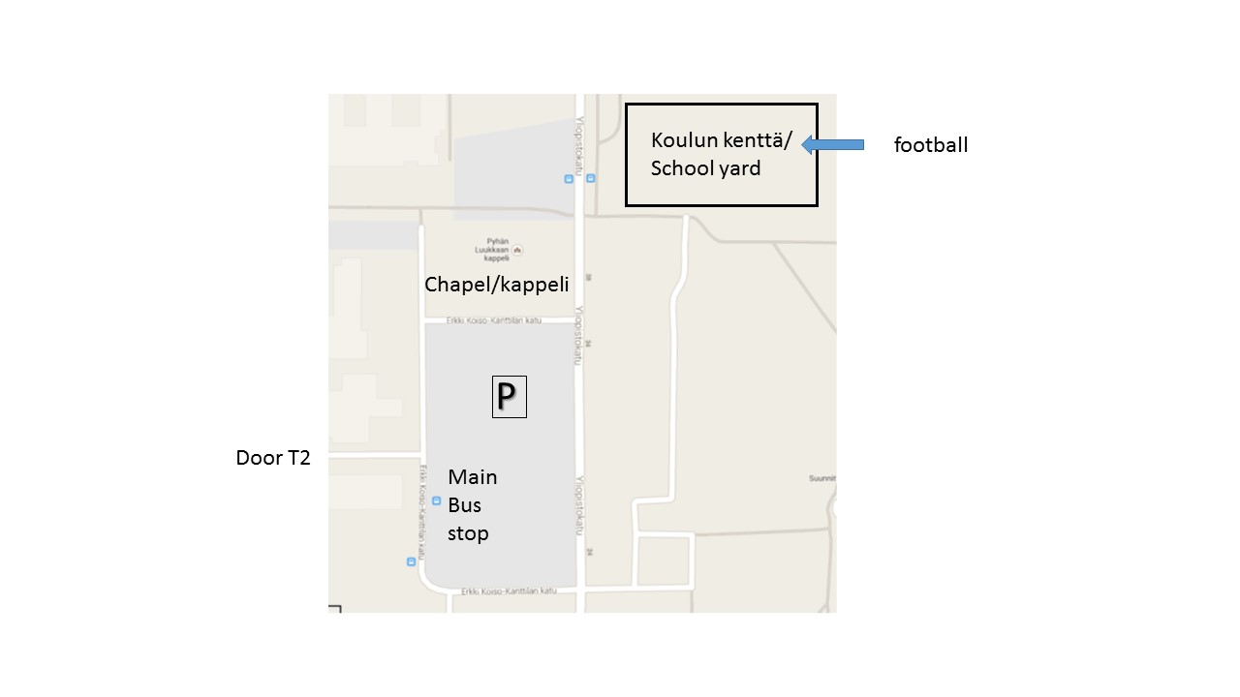
The school yard closest to us is available from 14:30 onwards

