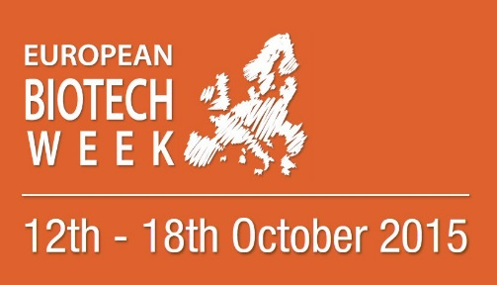

Helsinki, May 4, 2015

Call for the BioFinland Pitching Competition organized by Finnish Bioindustries

Finnish Bioindustries is celebrating the European Biotech Week October 12-18, 2015 by launching the BioFinland Pitching Competition for students in the field of biosciences in Finland.
The aim of the competition is to encourage students to take a more positive stand towards biobusiness and entrepreunership.
The Competition is organized by Finnish Bioindustries, the board of which chooses the Pitching finalists based on the applications. The Board of Finnish Bioindustries judges also the winner of the Competition.
The Application deadline is September 25, and the finalists for the Pitching Competition are announced on October 2.
The Pitching competition is organized during the European Biotech Week, on October 16.
The reward of the competition is 1000 €, which the team can use freely.
You can find the schedule, rules, instructions and the application form for the competition on the webpages of Finnish Bioindustries:

http://www.finbio.net/pitching-competition

Apply now, get professional feedback and win 1000 € !

Good luck with the competition!

Further information:
Carmela Kantor-Aaltonen
Director
Finnish Bioindustries
email: carmela.kantor-aaltonen@kemianteollisuus.fi
tel: 0504045166

