Come join us at the Nordic Perspectives recruitment event!

Providing possibilities across borders

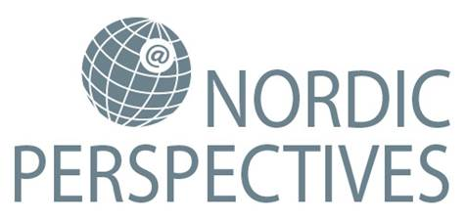

European (Online) Job Days 2017
International recruitment event on February 14th 2017 between 10-16

Nordic Perspectives is Finland’s official European Job Days event in 2017, and one of several similar recruitment events across Europe. A new recruitment concept where Online and Onsite recruitment blend into one seamless event. You can chat about work options with employers and experts from Finland and abroad. Seize the moment and find out more.

No matter where in Europe you are, you can join us Online. Register at www.europeanjobdays.eu Nordic Perspectives and you can browse job offers, put in your CV and during the event chat with employers and be interviewed. By registering you will make sure to get as much information as possible before the event is live. You will be sent information on registered employers and possible job offers even before the 14th of February.
Employers will be participating from different sectors and different countries but the main focus is on ICT, infrastructure construction and tourism. Employers and experts on international possibilities will be Online and Onsite to answer questions and provide information on job opportunities. Countries participating include e.g. Germany, Sweden, Norway, Spain, The Netherlands, Denmark.

Join us!
Online: www.europeanjobdays.eu
Onsite: Hotelli Radisson Blu, Oulu

Additional information and program at
www.te-palvelut.fi/europeanjobday (English)
Nordic Perspectives is part of the operations of the EURES (European Employment Services), and is coordinated by the North Ostrobothnia, Lapland and Kainuu TE Offices in collaboration with the “Labour Mobility in Europe” project of the North Karelia ELY Centre.

