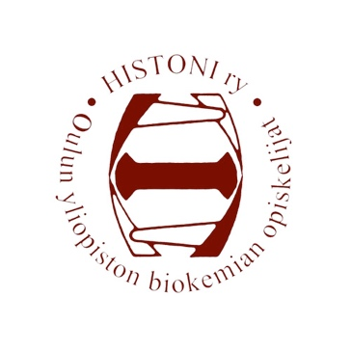
Histoni ry, Biochemistry students of University of Oulu
Meeting invitation
Meeting of the board 12/2020
Kontinkangas, Tellus Carpi; remote meeting, Histoni ry’s
Discord server
7.10.2020, at 16:00

Agenda 12/2020

- Opening of the meeting
- Legality and quorum
- Election of the examiners of the minutes
- Approval of the agenda
- Acceptation of the previous meetings’ minutes
- Notifications
- OLuT greetings
- Halloped greetings
- OYY-terveiset
- Purchases
- Acceptation of the bills and other finances
- Overalls
- Spreadshirt
- Anniversary Ball
- Honorary Badges
- Past Events
16.1 OLuT ry’s freshmen orienteering 16.9.
16.2 Freshmen party 30.9.
- Coming events
17.1 Bike ride to Nallikari
17.2 Excursion to Pilpasuo
17.3 Halloween grilling
17.4 Pre-Christmas Party
17.5 Board Overture
17.6 Annual Autumn Meeting
17.7 Other autumn events
- Other business
- Closing of the meeting

In Oulu 6.10.2020

_______________________________
Susanna Kirsilä, chairman

