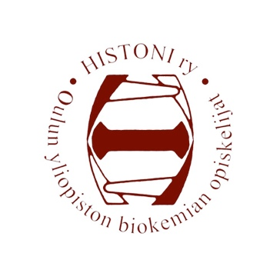
Histoni ry, Biochemistry students of University of Oulu
Meeting invitation
Meeting of the board 2/2020
The Linnanmaa guild complex
7.2.2020, at 17:00

Agenda 2/2020

- Opening of the meeting
- Legality and quorum
- Election of the examiners of the minutes
- Approval of the agenda
- Notifications
- Greetings from OLuT ry
- Greetings from OYY
- Greetings from Hallopeds
- Purchases
- Acception of the bills and other finances
- Acception of new guild members
- Overalls
- Tutors 2020
- Coming events
14.1 The Annual Spring meeting 9.3.
14.2 KV-grilling 10.2.
14.3 Overalls party 12.2.
14.4 Making of the Valentine’s Day cards at Kontinkangas 14.2.
14.5 Sitnings with Kontinkangas guilds
14.6 Histombly 20.-22.3.
14.7 Sika Säkissä 8.4.
14.8 Other events
- Past events
15.1 Kemiat Kohtaa 30.1.-1.2.
15.2 Sitnings with Kulti ry 6.2.
- Other bussiness
- Closing of the meeting

In Oulu 4.2.2020

_______________________________
Susanna Kirsilä, chairman of the board

